# Analysis of mouse data

## Method

I have analysed each cell type separately. I converted the proportion of cells of the given type to the logit scale, and fitted a Normal linear mixed model, with mouse type and time as the predictors and the logit proportion as response. Time was included as a 5-level factor.

I included a random intercept for each mouse, to take into account the correlations of repeated observations of the same mouse. I also considered stroke size as a predictor. The variables of interest are the mean proportion of cells for the two types of mice, at each point in time, as well as the interaction between mouse type and time.

I have not made any adjustments for multiple comparisons. All confidence intervals are 95%.

There was a single occurrence of a zero count, and this I adjusted to the value one for practical reasons. All analysis was done in R version 3.6, with packages NMLE and LME4.

## Results

Initial analyses showed that cell counts for female mice, and for PLT mice, were quite different from male WT and T2 mice (in which we are primarily interested), so I removed them from the analysis. I also found stroke size does not add to the explanation of the data, so I did not consider this further.

I have calculated confidence intervals for the mean proportion, as predicted by the model. These are shown in the figure below. An asterisk on the x-axis shows that the difference between the two types of mice is significantly different from zero, at that time-point.

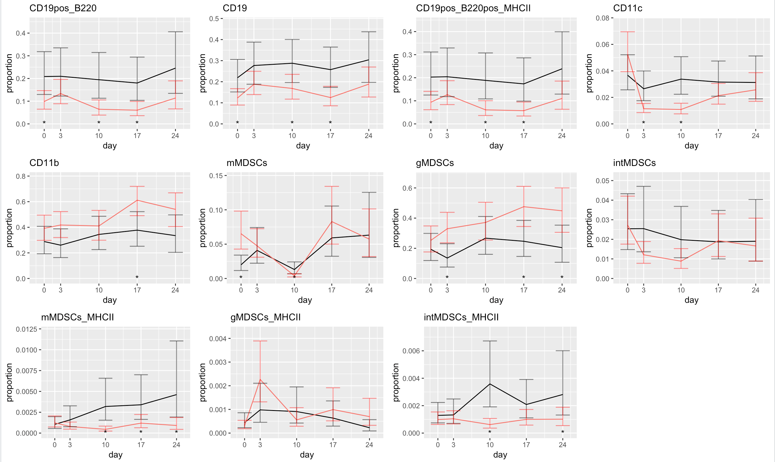

Confidence intervals for predicted mean cell proportions. Red: T2 mice; black: WT mice.

Comparing WT mice and T2 mice at the same day, we find the following:

* The mean proportions for CD19pos_B220, CD19, CD19pos_B220pos_MHCII to be *lower* for T2 mice at days 0, 10 and 17.
* For CD11c, this is the case at days 3 and 10.
* mMDSCs_MHCII proportions are lower in T2 mice on days 10,17 and 24
* intMDSCs_MHCII are lower in T2 mice on days 10 and 24.
* CD11b proportions are *higher* in T2 mice at day 17;
* mMDSCs at days 0 and 10;
* gMDSCs at days 3,17 and 24;

There are no significant differences for intMDSCs and gMDSCs_MHCII cells.

## Analysis of variance.

|  |  |  |  |
| --- | --- | --- | --- |
| **Celltype** | **Mouse type** | **Period** | **interaction** |
| CD19pos_B220 | **0.0465** | **0.0094** | 0.5118 |
| CD19 | **0.0188** | **0.0184** | 0.8498 |
| CD19pos_B220pos_MHCII | **0.0480** | **0.0086** | 0.5476 |
| CD11c | 0.0003 | 0.0284 | **0.0036** |
| CD11b | **0.0091** | 0.0583 | 0.4817 |
| mMDSCs | < 1e-5 | 0.2614 | **0.0023** |
| gMDSCs | **0.0349** | **0.0283** | 0.2904 |
| intMDSCs | 0.1039 | 0.2014 | 0.3143 |
| mMDSCs_MHCII | 0.3620 | 0.0126 | **0.0219** |
| gMDSCs_MHCII | **0.0005** | 0.5438 | 0.0926 |
| intMDSCs_MHCII | 0.8351 | **0.0168** | 0.0567 |

Analyis of variance: p-values for linear regression at the logit scale.

The interaction between mouse type and period is significant for cell types CD11c, mMDSCs and mMDSCs_MHCII: This tells us that, for these cell types, the time trajectory differs for the two types of mice, more than would be explained by chance.

For the remaining cell types, we see no evidence that the two types of mice respond differently over the five time periods. We see, however, significant main effects for all cell types, with the exception of intMDSCs.

In what follows, we look at this in detail, for each cell type.

## CD19pos_B220

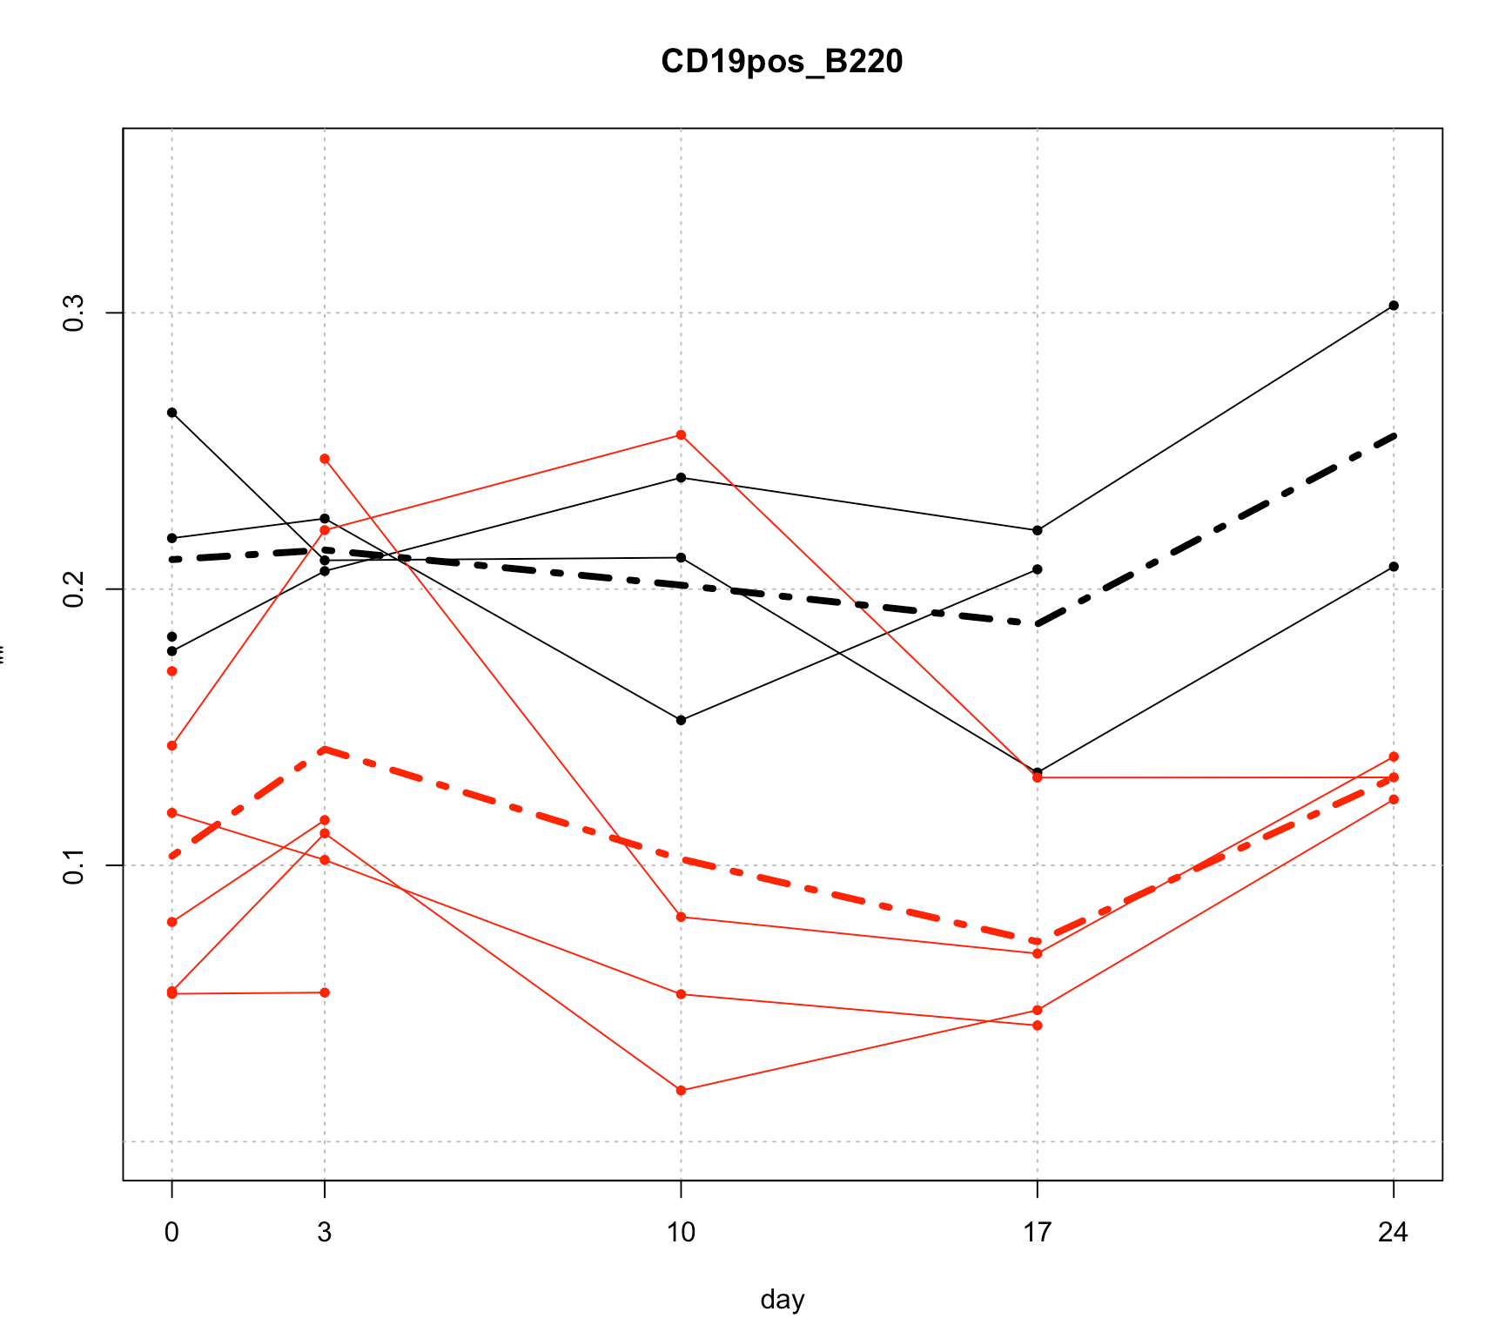

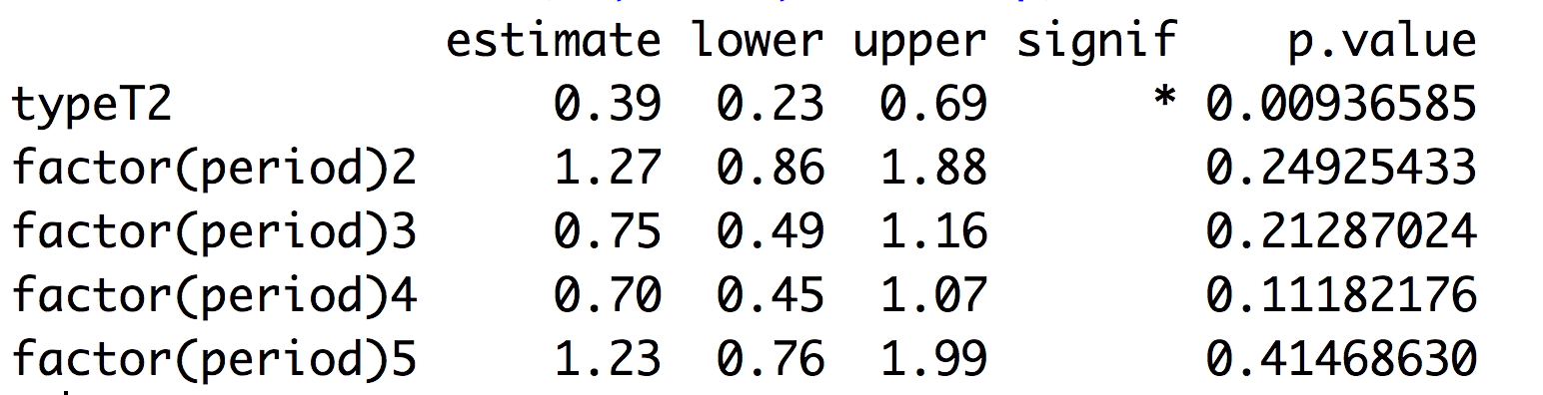

The estimates and CI’s are to be interpreted as odds ratios for the mean. We can say that we are between 0.23 and 0.69 times as likely to see this type of cell at time 1 for a T2 mouse, compared to a WT mouse; Time does not appear to be a significant factor for this cell type.

We can also compare T2 mice with WT mice at the same time period, and then we have the following:

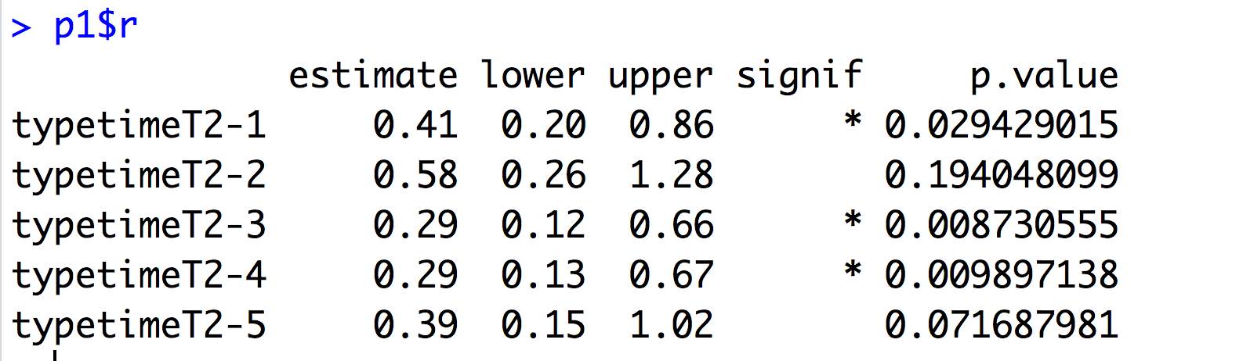

## CD19

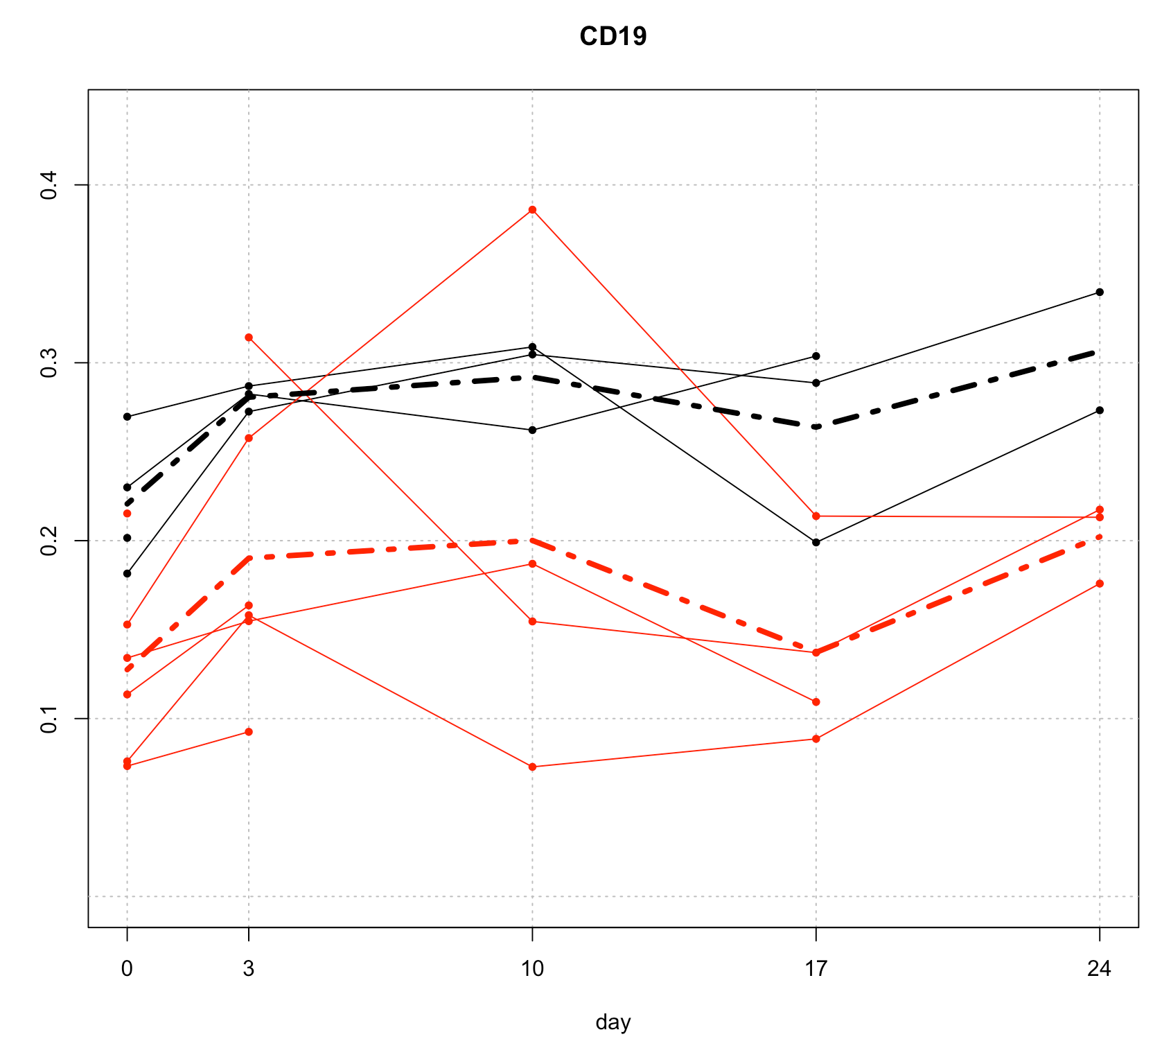

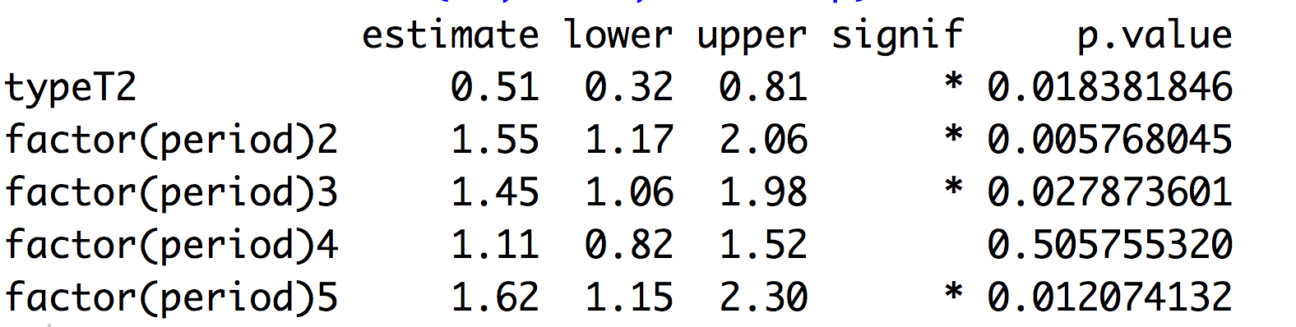

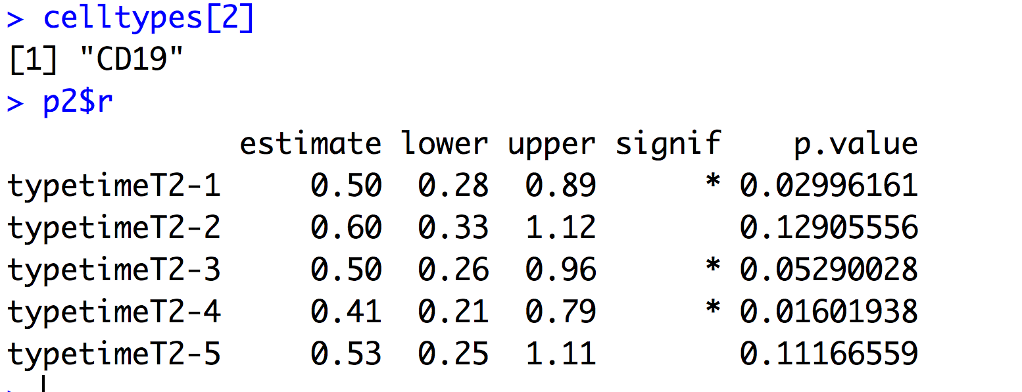

## CD19pos_B220pos_MHCII

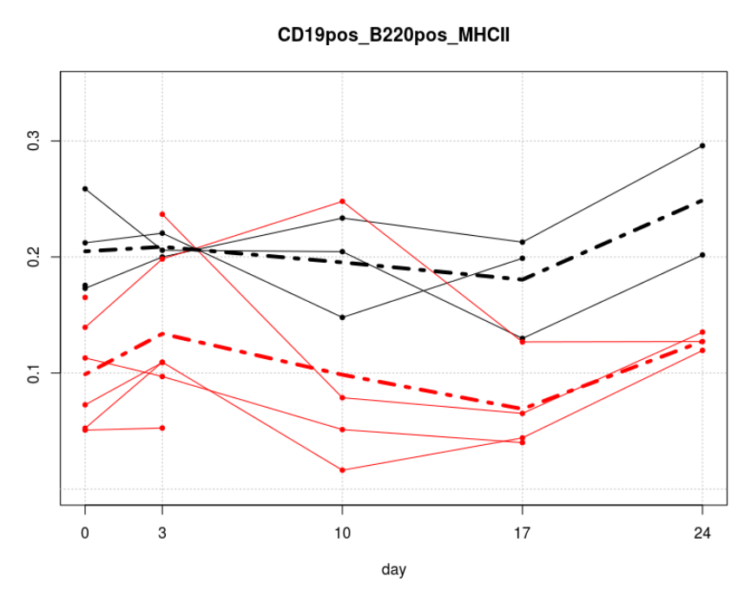

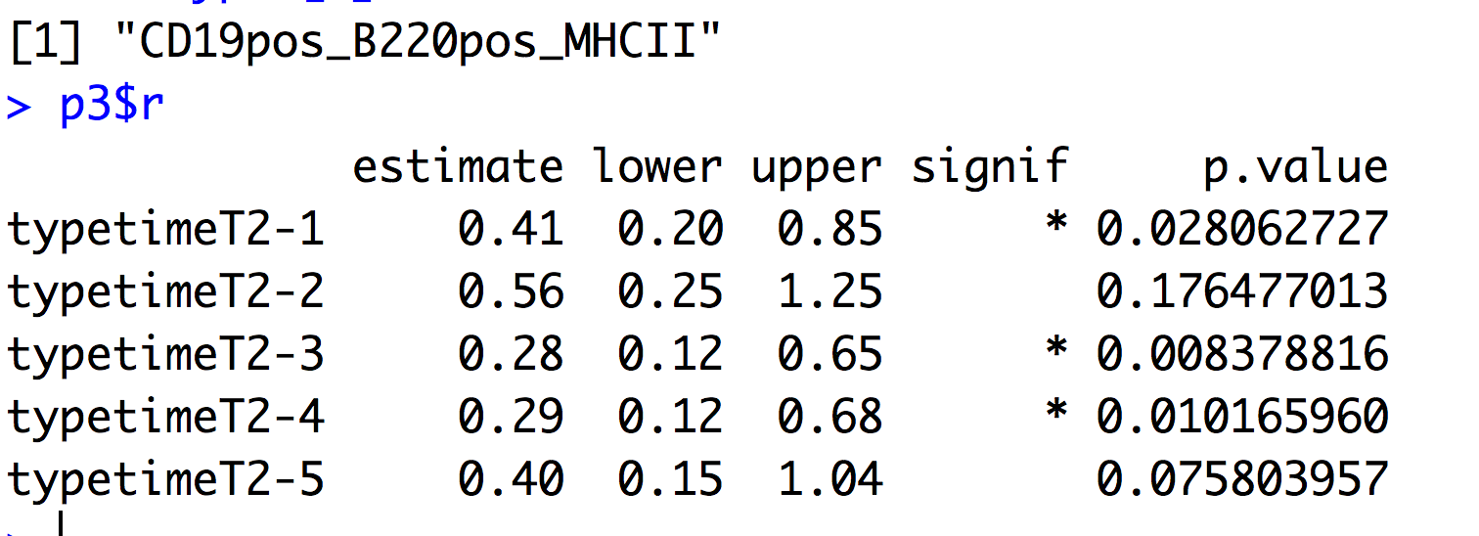

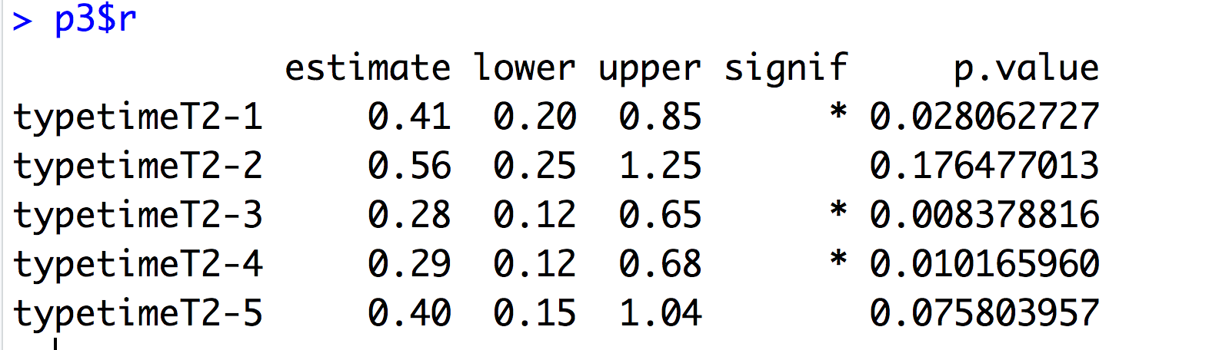

### CD11C

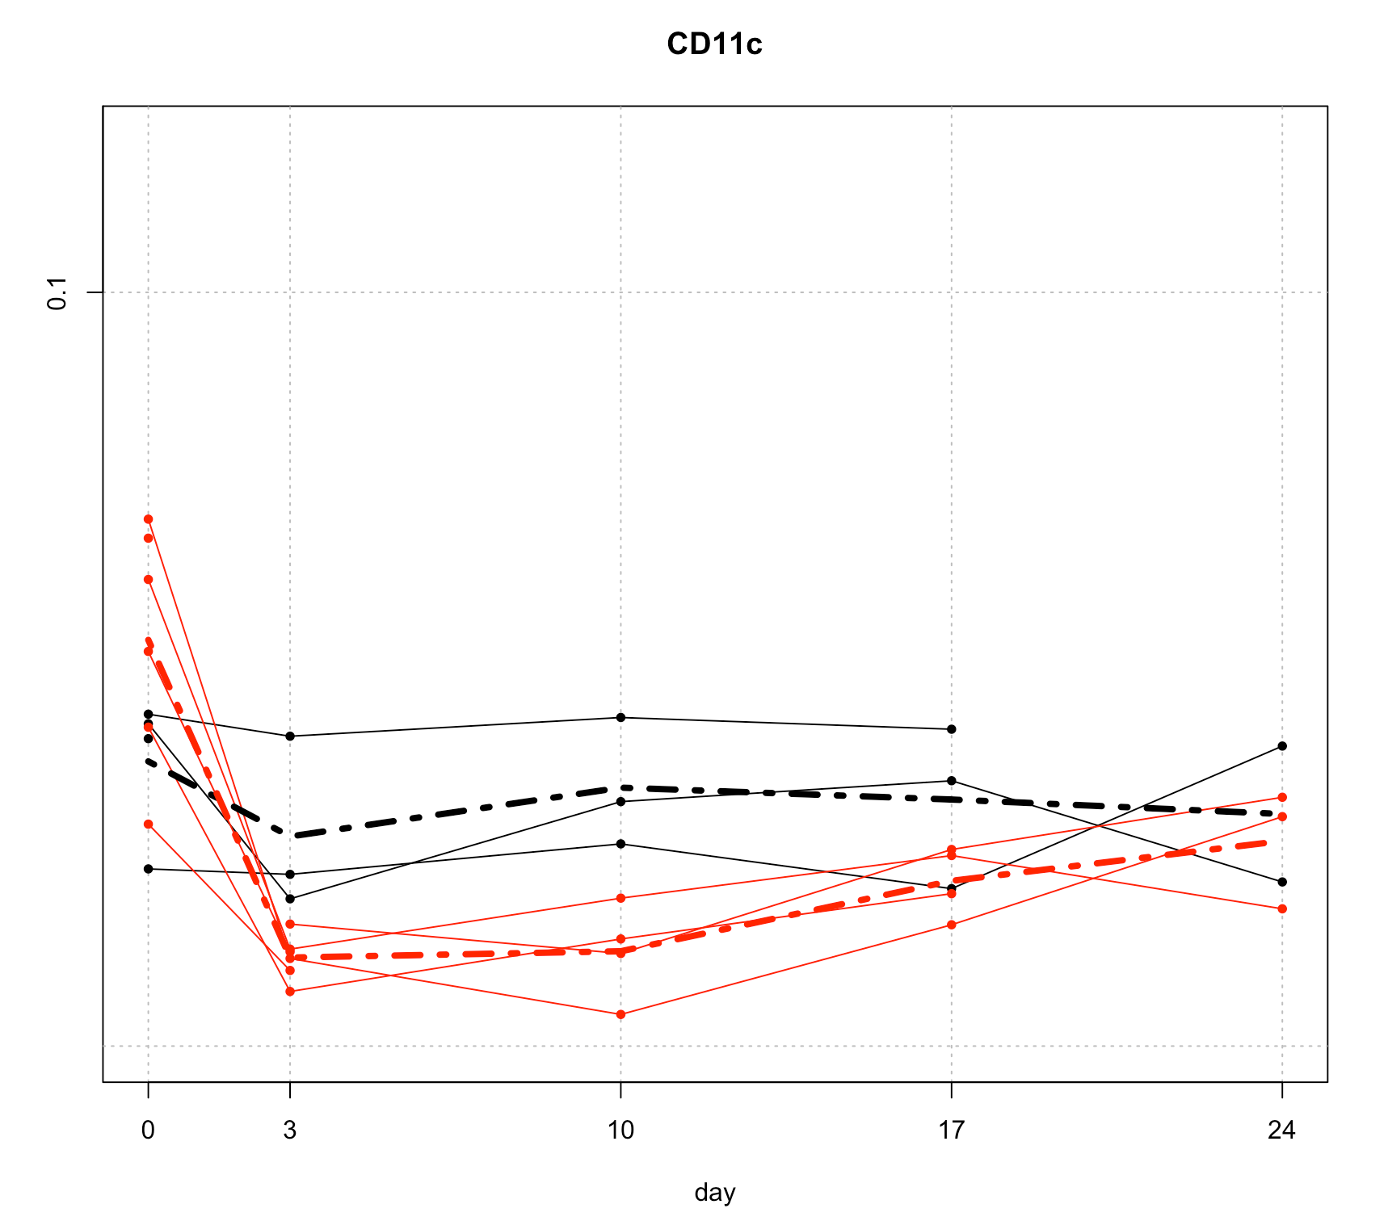

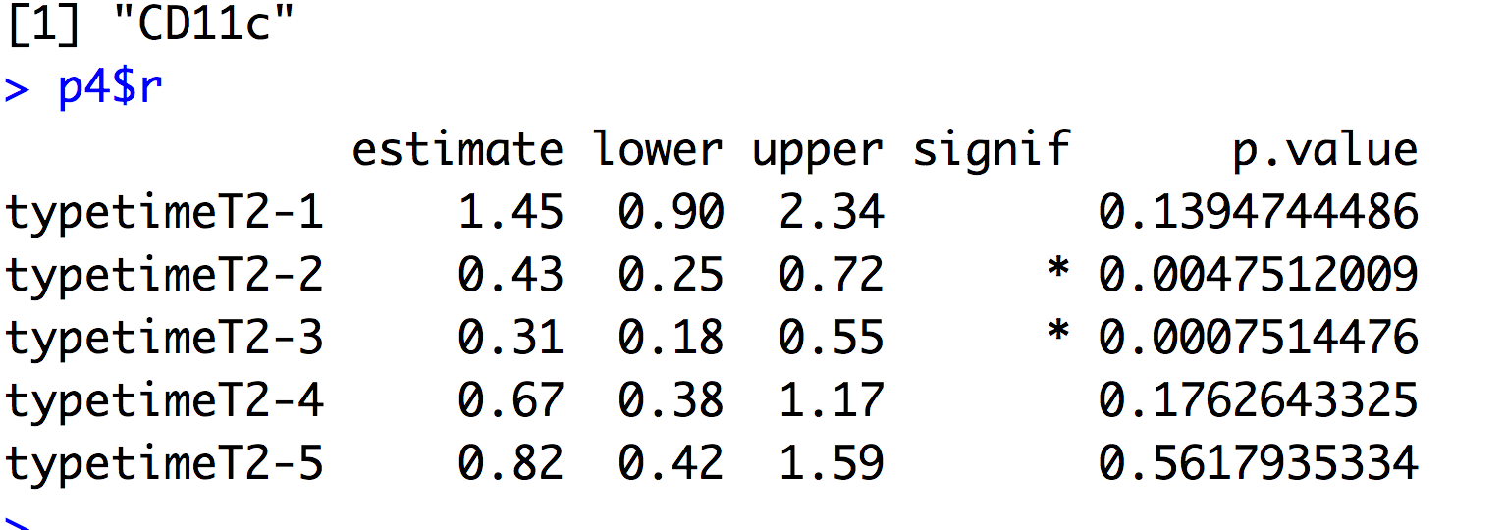

## CD11b

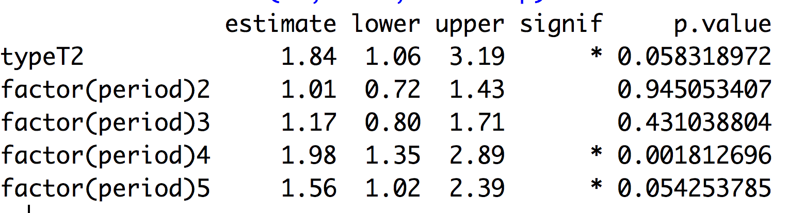

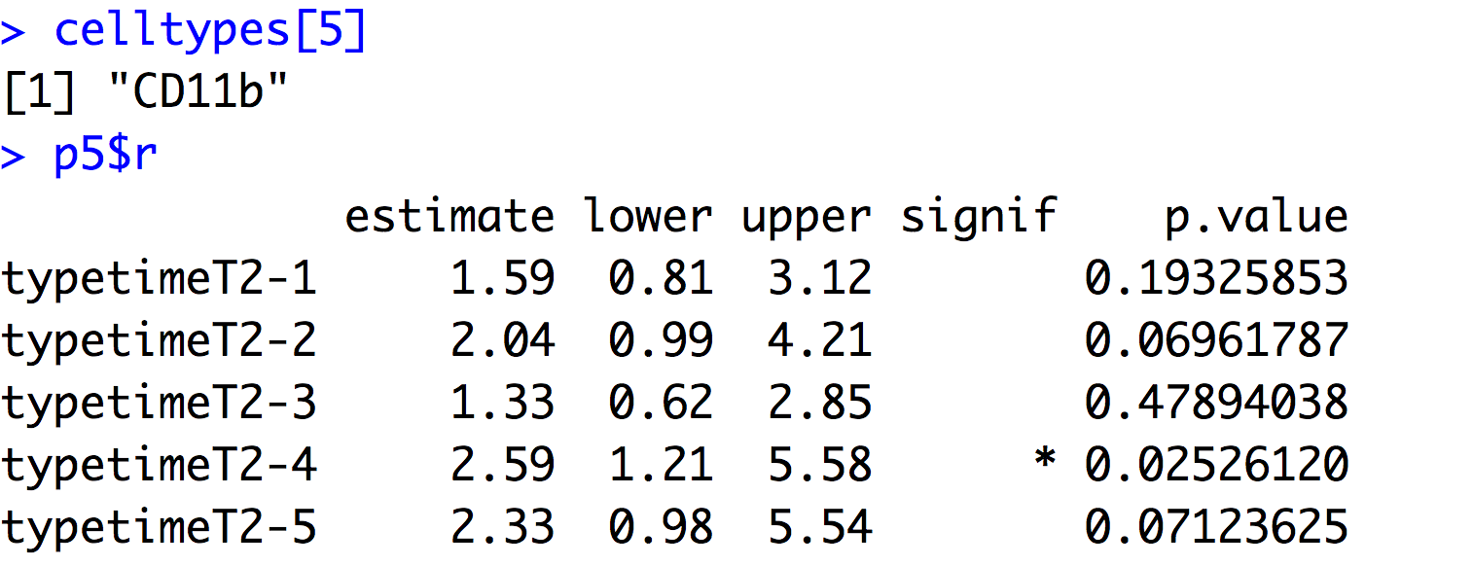

## mMDSCs

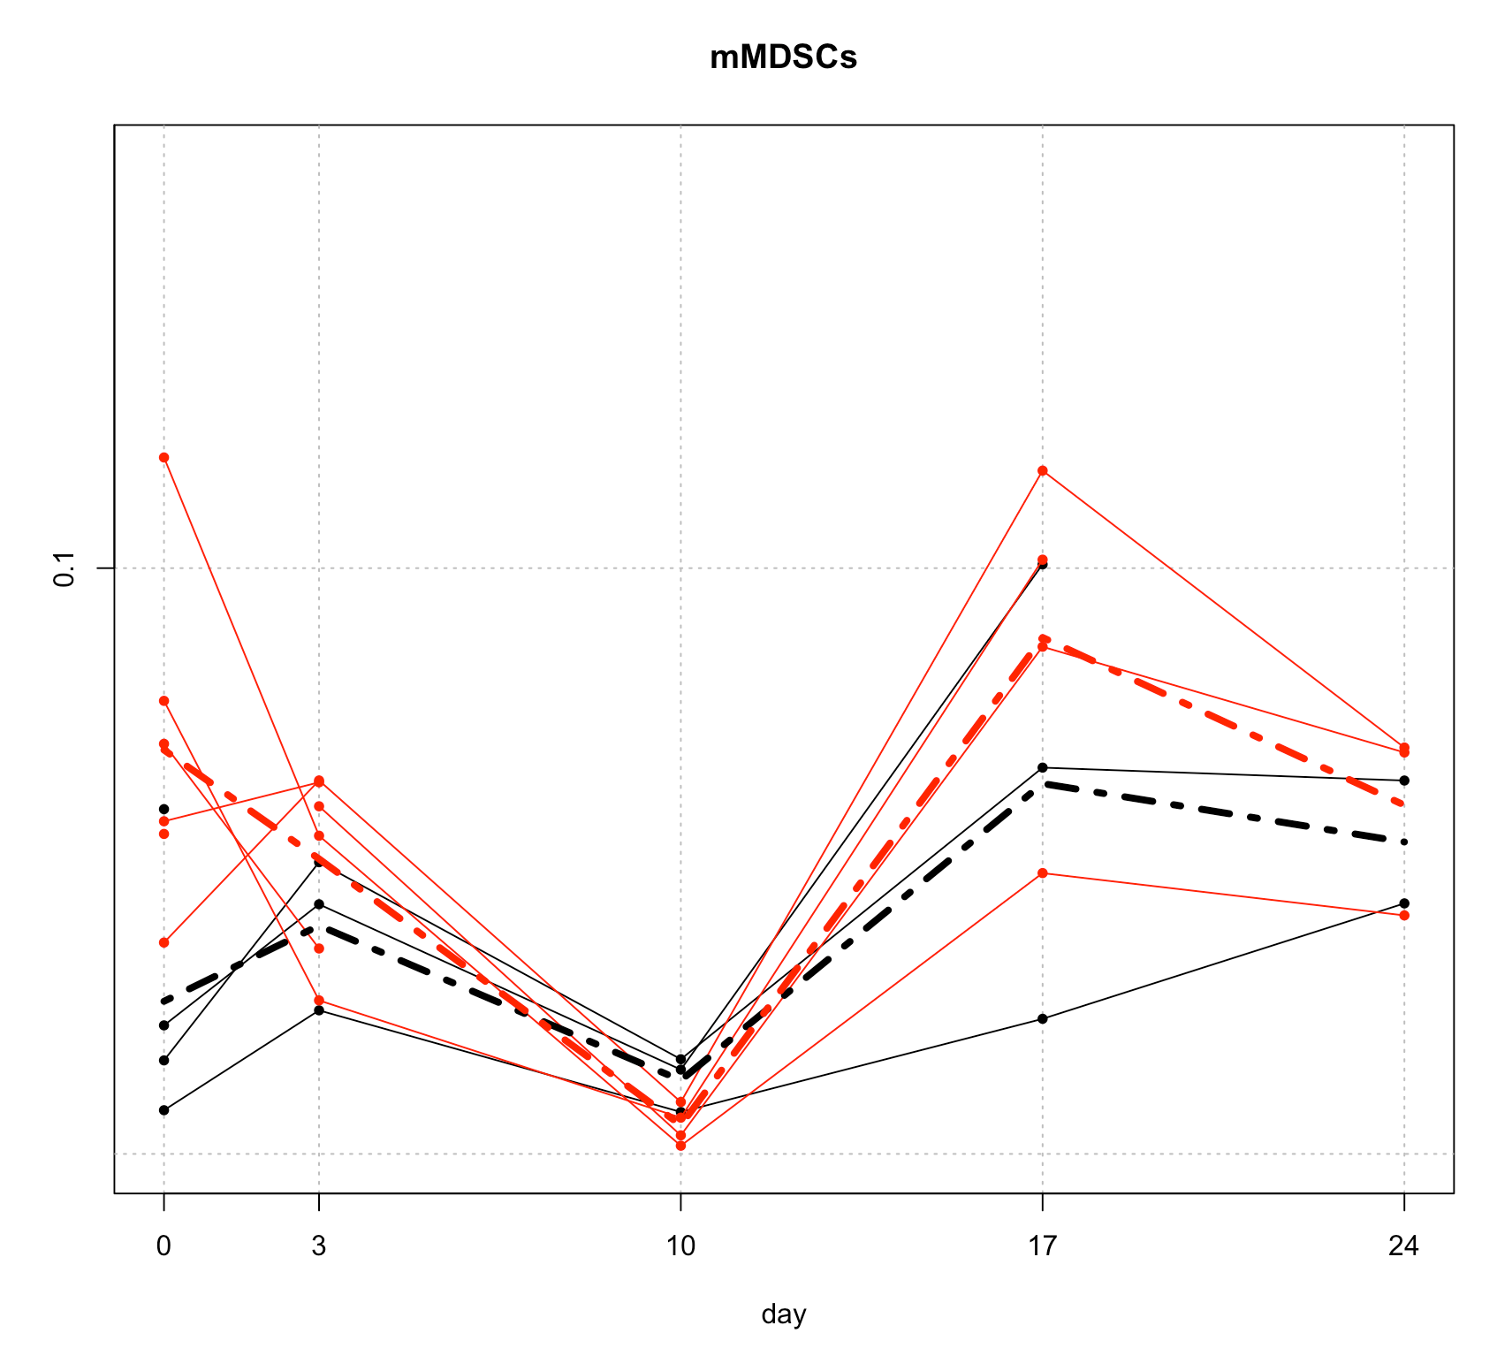

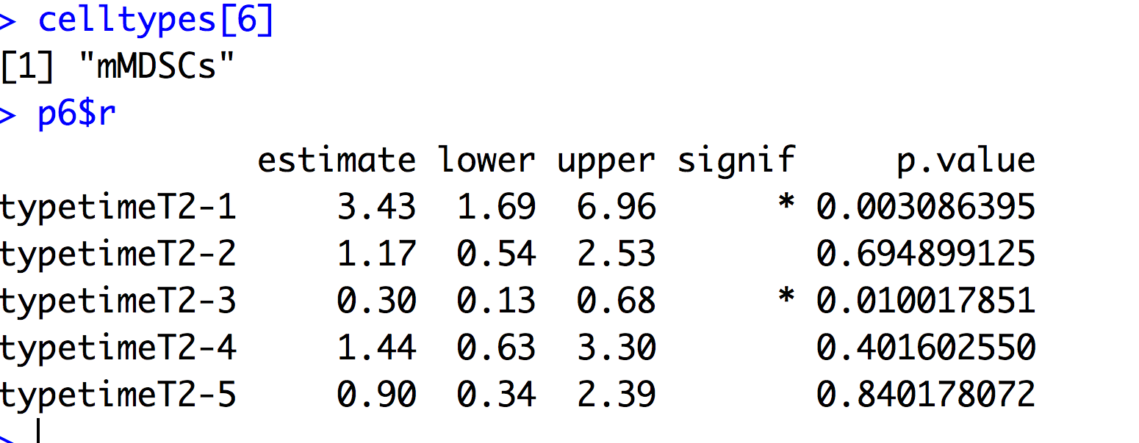

## gMDSCs

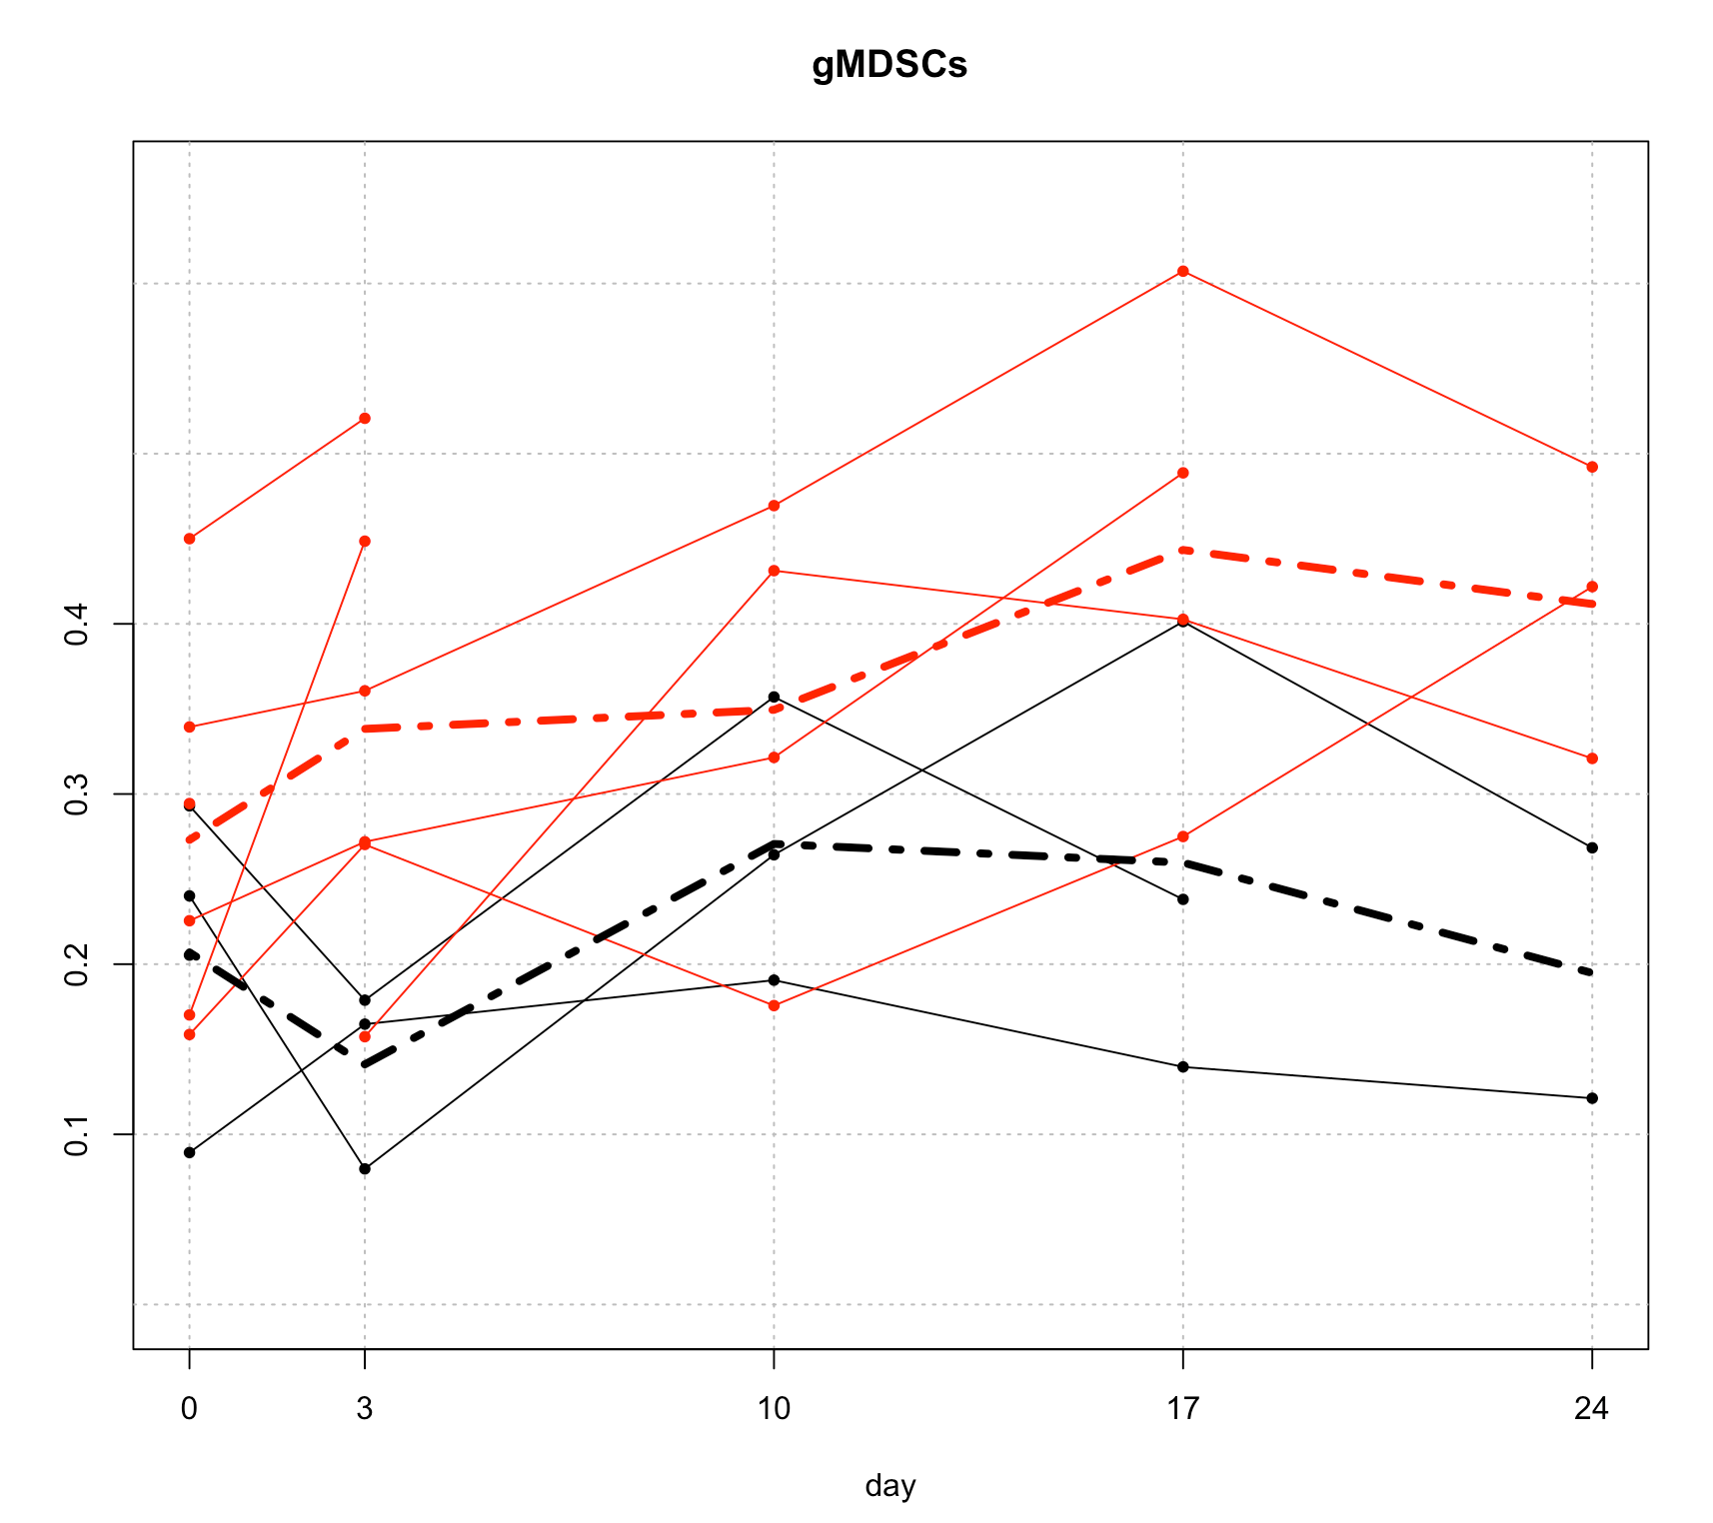

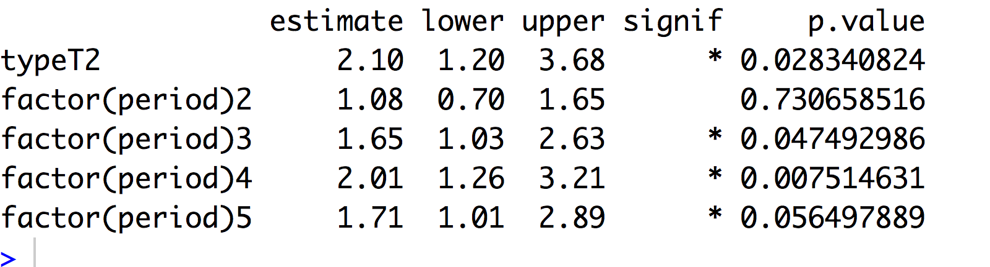

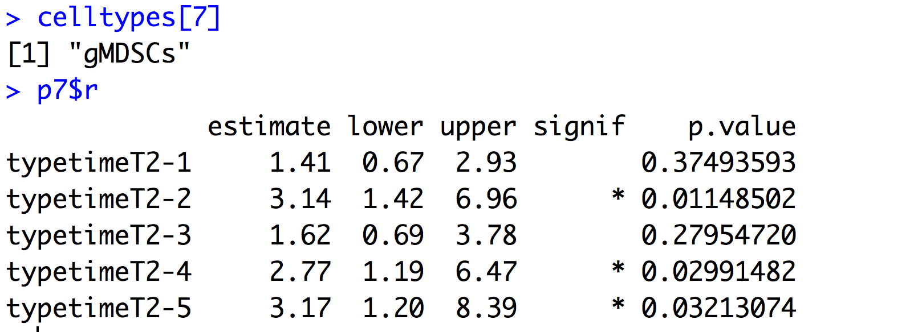

## intMDSCs

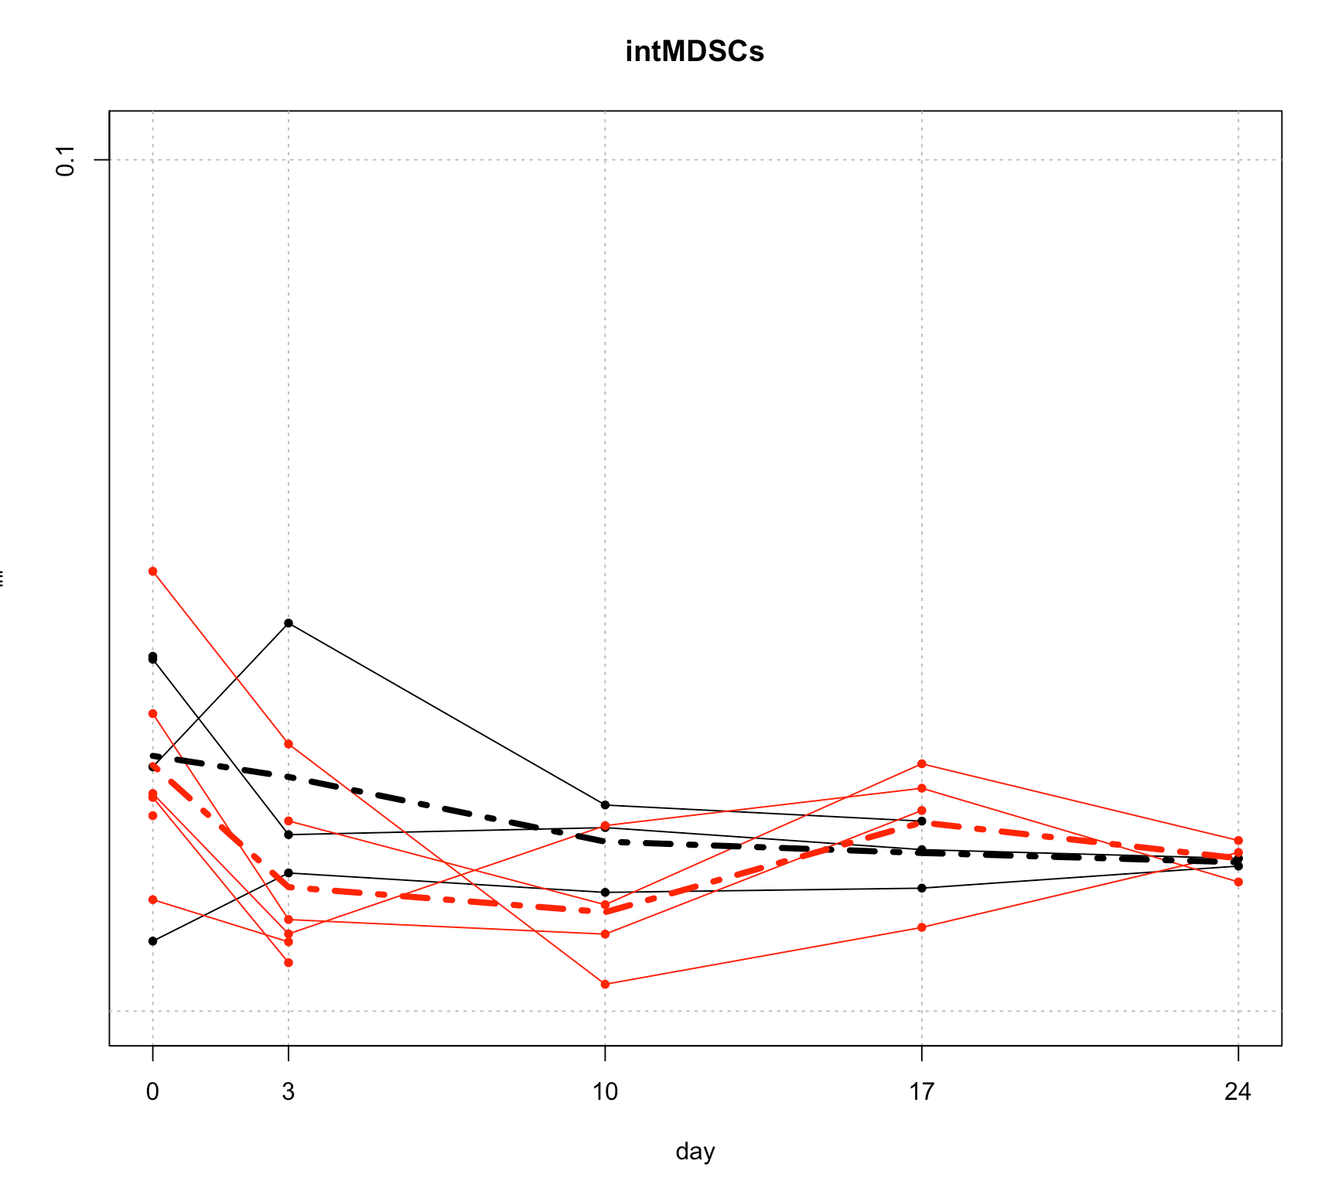

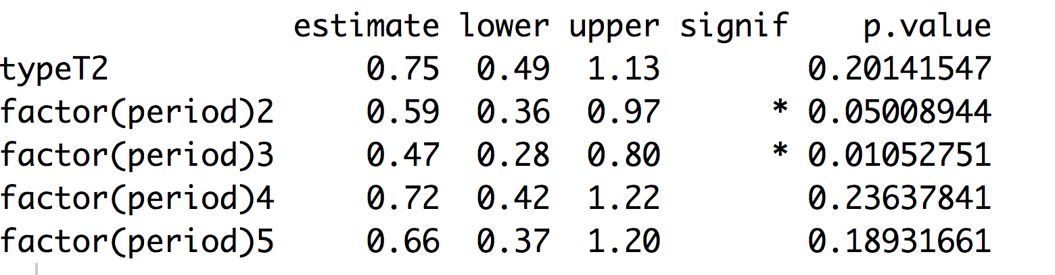

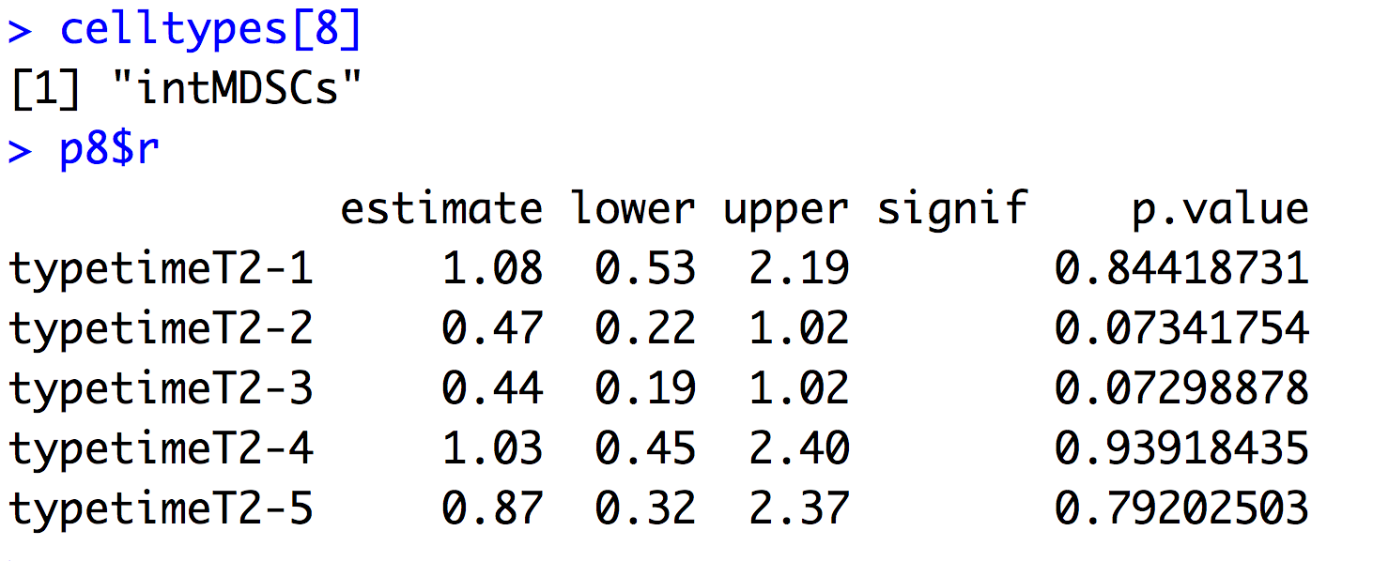

## mMDSCSs_MHCII

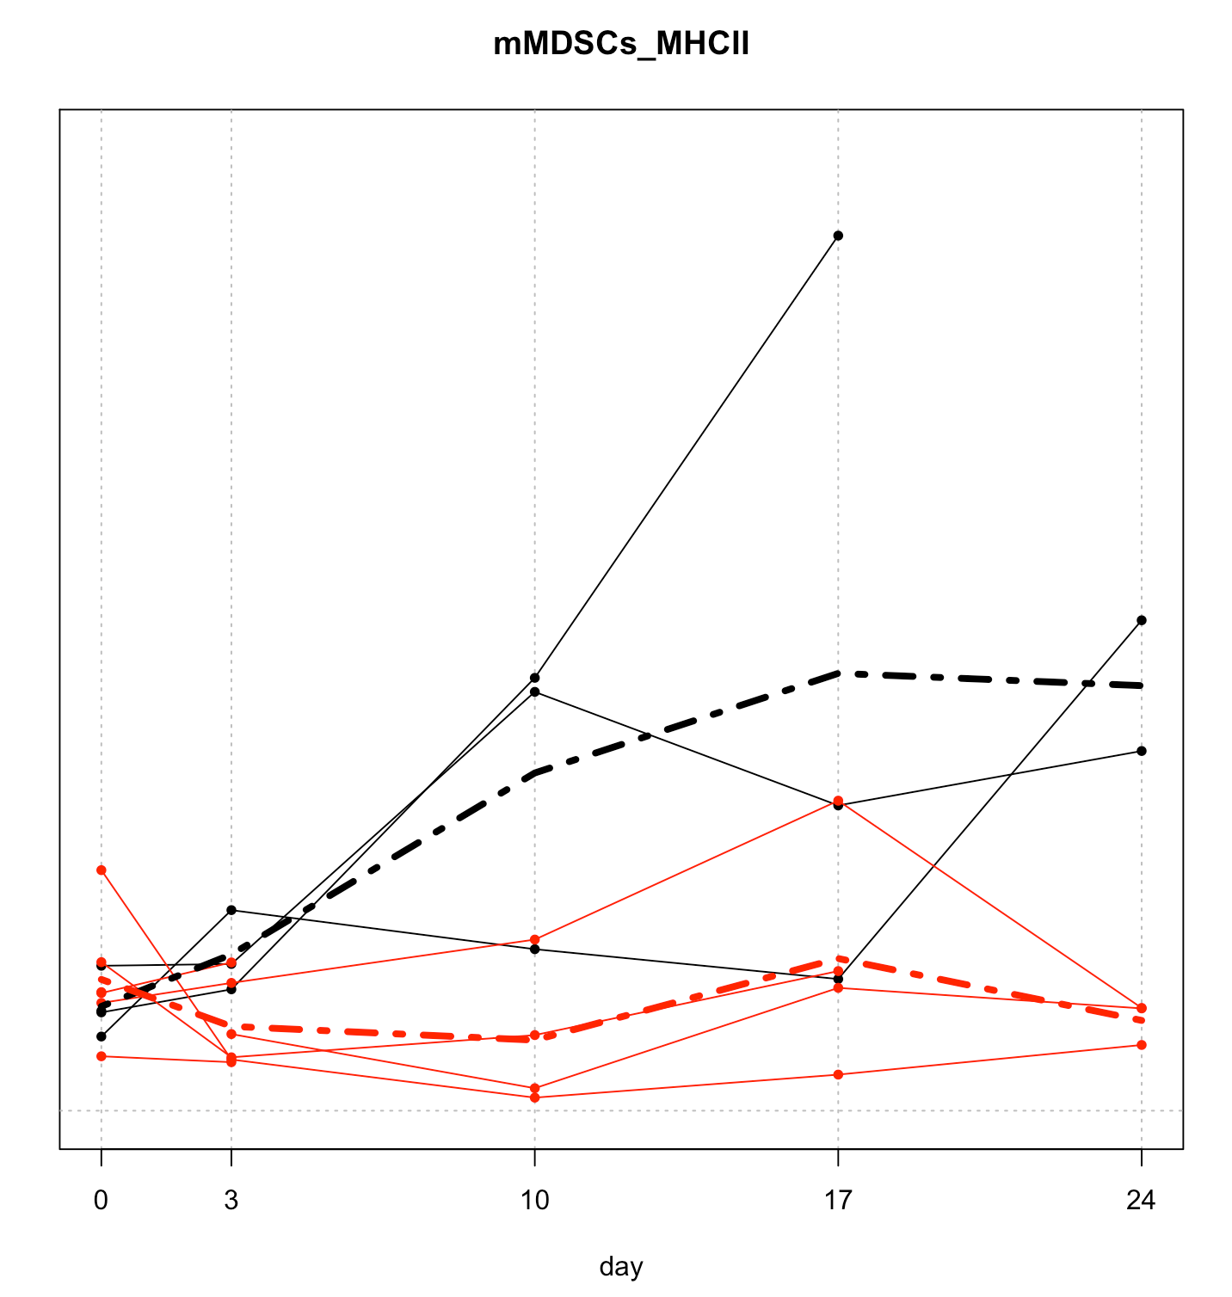

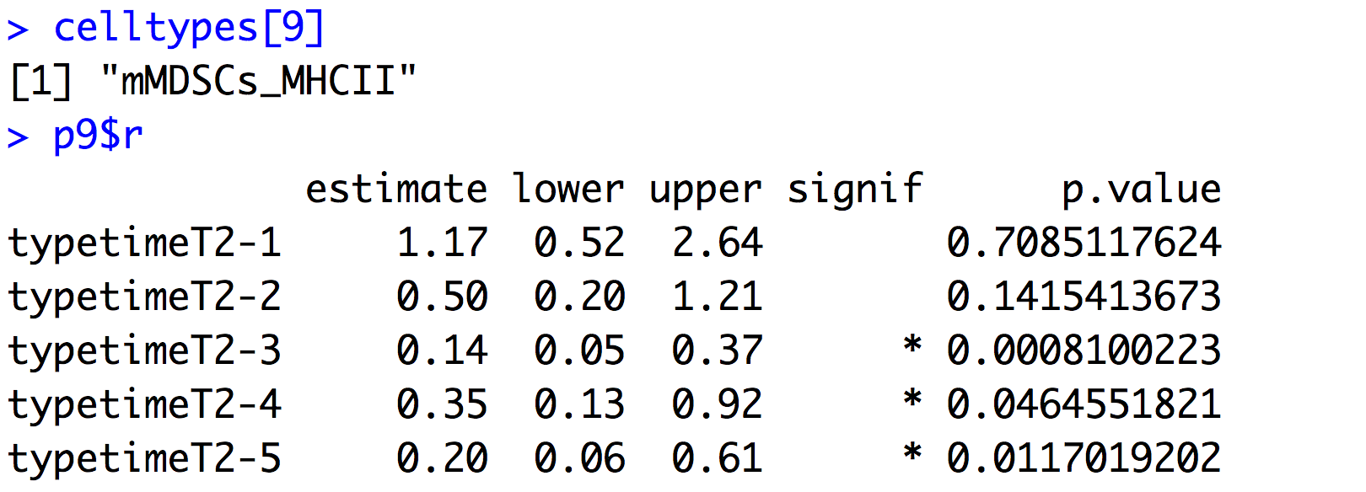

## gMDSCs_MHCII

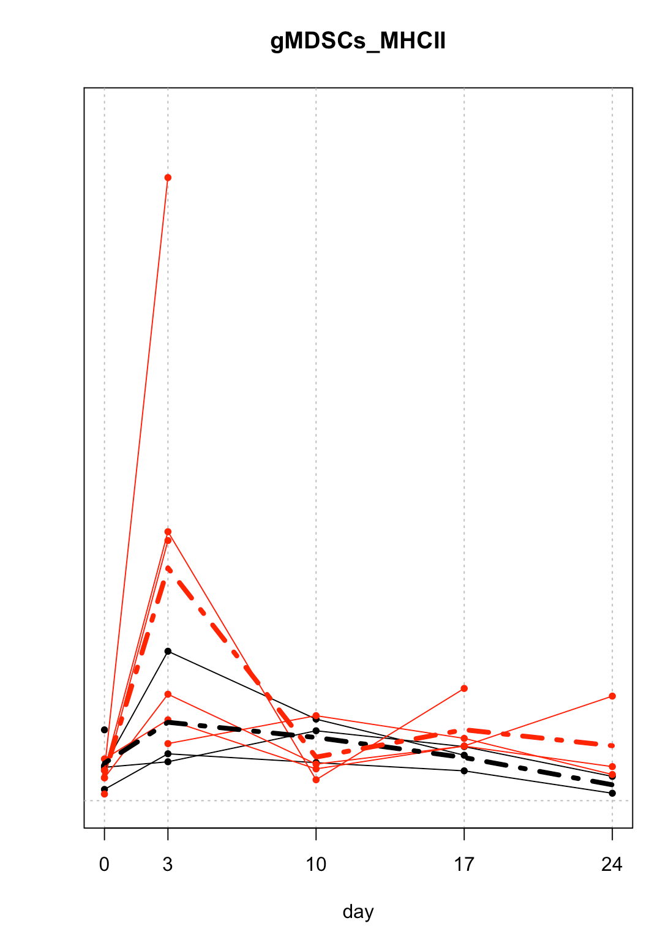

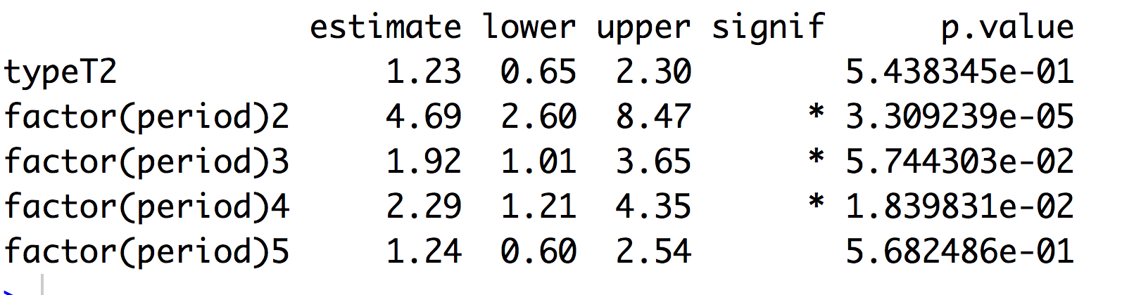

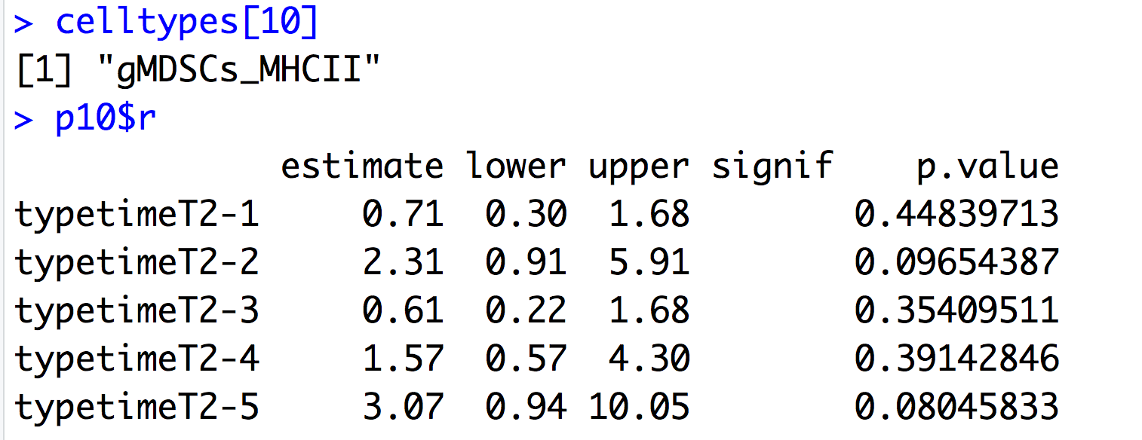

## intMDSCs_MHCII

